# Nuclear Fusion

The fusion reactions that happen in the sun require such high temperatures and pressures that they cannot be reproduced on Earth. A different fusion reaction is being experimented with on Earth.

## The proton-proton (p-p) chain

The reaction process depicted above is the dominant fusion mechanism in light stars such as our sun. (In heavier stars, a more complicated process known as the CNO cycle is more common.) In the p-p chain, two pairs of protons fuse, forming two deuterium atoms (H-2). Each deuterium atom then fuses with an additional proton to form helium-3. The two helium-3 nuclei then fuse to create beryllium-6, which is unstable and disintegrates very quickly into two protons and an alpha particle. The process also releases a total of two neutrinos, two positrons, and two gamma rays. The positrons annihilate quickly with electrons in the plasma, releasing energy in the form of additional gamma rays. The neutrinos interact so weakly that they fly right out of the sun.

## The deuterium-tritium (D+T) fusion reaction

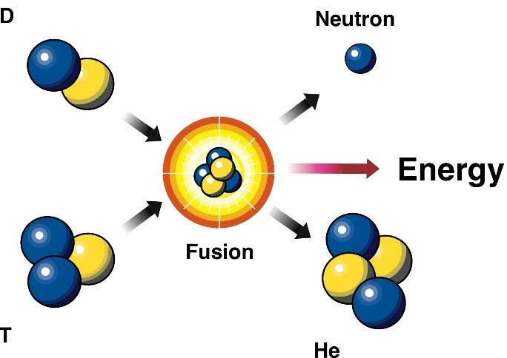

The D+T reaction has the highest reaction rate at the plasma temperatures which are currently achievable; it also has a very high energy release. These properties make it a good candidate for use in a future man-made fusion reactor.

## Calculating Energy of Fusion Reactions

The energy released by fusion reactions can be calculated in the same way as fission:

1. Determine the mass defect (Δ*m*) by subtracting the mass of the products from the mass of the reactants.
2. Calculate the amount of energy depending on the units you are using:
   1. If your mass is in atomic mass units (u), multiply by 931 to find the energy released in megaelectron-volts (MeV)
   2. If your mass is in kilograms (kg), multiply by *c*2 to find the energy released in Joules (J)
3. Convert your amount of energy to J / MeV if required.

## Questions

1. Approximately how much energy is released in a single D+T fusion event?
2. Why is the D+T process more useful for fusion reactors than the p-p chain?
3. Excess neutrons from the D+T process can be absorbed by lithium-6 atoms, forming tritium (H-3) which can then be used as fuel in future D+T reactions. Write a full equation for this process and calculate the amount of energy it releases.
4. Write equations for the three main reactions in the proton-proton chain and calculate the total amount of energy released by the entire chain.